Name: Haseem Farooq

Student ID: 467020

Section: ME 15/C

lab manual 5

HOME TASK

1. Write a program in C++ to find LCM of any two numbers using HCF.

INPUT:

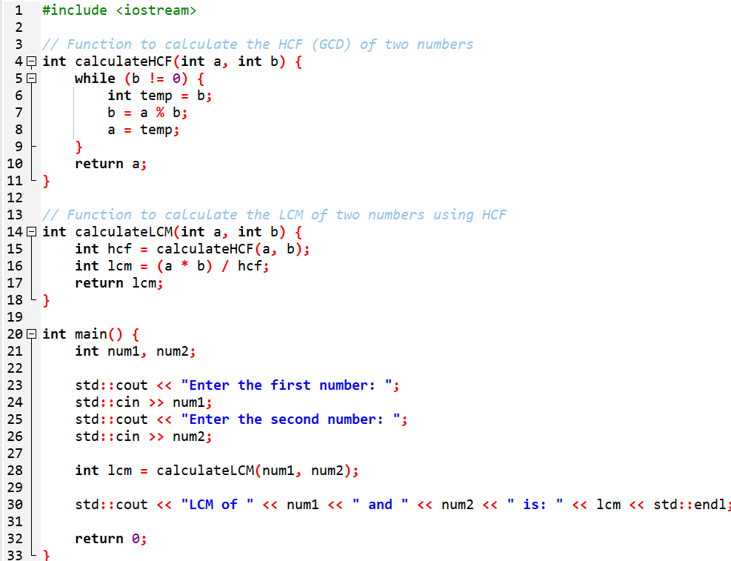

OUTPUT:

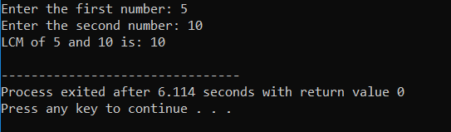

1. Write a program in C++ to find out the sum of an Arithmetic progression series.

INPUT:

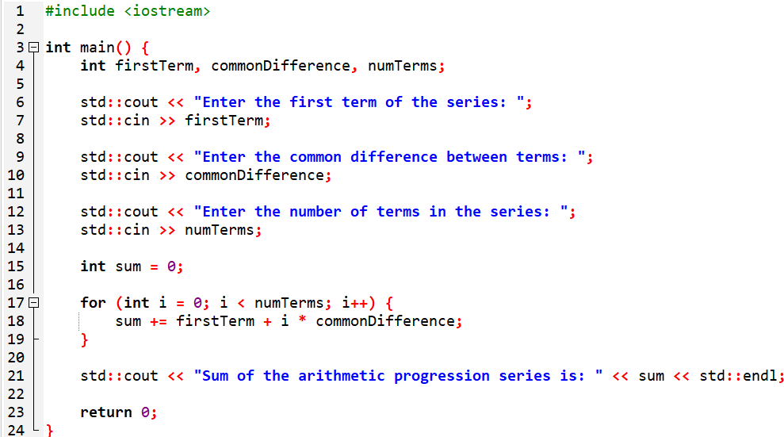

OUTPUT:

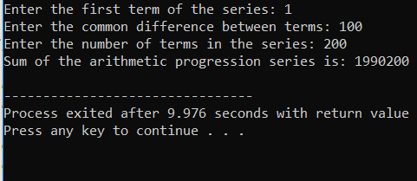

1. Write a program in C++ to create a diamond.

INPUT:  
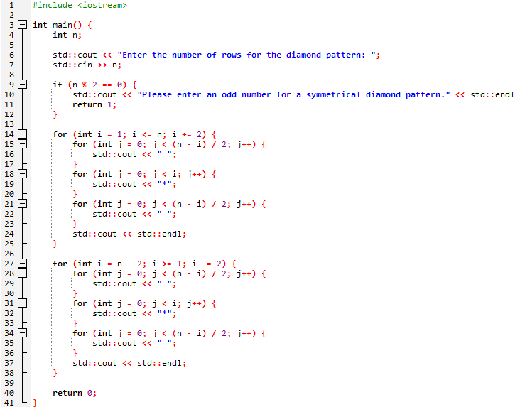  
OUTPUT:  
 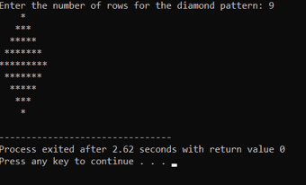

1. Write a program in C++ to convert a decimal number to binary number.

INPUT:

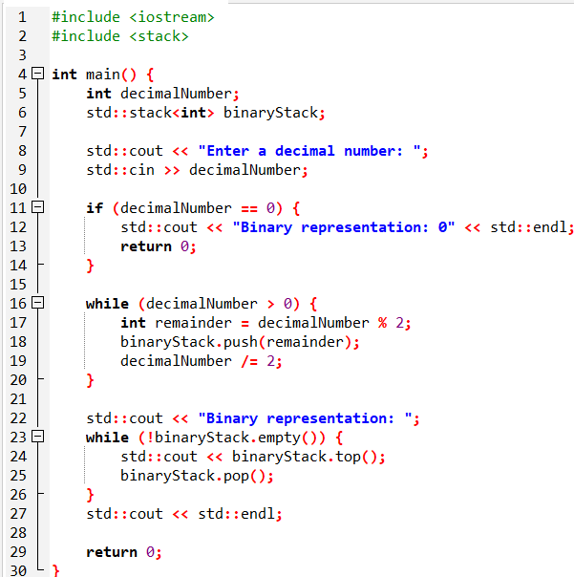

OUTPUT:

